Customer:  Purchase Order Number: | VPT Rad  TBD
VPT Rad Job Number: | TBD
Test Date: | 08/02/2024
Manufacturer Part #:  Manufacturer Lot #:  Manufacturer Wafer #:  Serial Numbers (Tested / Control): | VISHAY – IRF740PBF  S51K053.1  NA  BIASED: SN# 1-5 VDS / 6-10 VGS  CONTROL: SN# 11, 12
Manufacturer Date Code:  Trace Code: | 2411  NA
Tested Quantity: | 10 DUTS - 2 CONTROL
Set-Up/Spare Quantity: | 0
Package Type: | TO-220
Test Standard(s) and/or Test Documents: | Testing WAS PERFORMED USING THE PROCEDURES APPROVED BY DLA FOR OUR DLA LAND AND MARITIME-VQ COMMERCIAL LABORATORY SUITABILITY AND TESTING CONFORMS TO MIL-STD-750/883 method 1019, CONDITION A.
Electrical Test Conditions:  Dose Rate: | TEST LEVELS: PRE, 5K, 10K, 15K, 20KRAD(Si)  171rad(Si)/s (SEE APPENDIX D: EXPOSURE REPORT)
Test Software: | IRF740PBF.T60
Applicable Documents:
Applicable Documents: | AD2: VISHAY IRF740 DATASHEET
Applicable Documents: | AD3: VPTRAD QUALITY ASSURANCE PLAN QA-1

Overview and Background

The purpose of this test was to characterize performance changes in the Devices Under Test (DUT) due to the effects of Total Ionizing Dose (TID). The scope is to evaluate how the subjected devices perform once exposed to Cobalt-60 gamma photons at various increasing levels of exposure.
Table 1. Overview of Results
Summary of the PASS/FAIL results
Note: Orange Indicates KTL Specifications Failure; Red Indicates Device Specifications Failure.

Summary/Conclusion

Samples were electrically characterized after exposure to customer specified levels. All tests were performed in conformance with the conditions and requirements described by MIL-STD-750/883 Test Method 1019. VPT Rad has DLA Laboratory Suitability for this test method. Samples were tracked in process using a TRAVELER, found in Appendix C.

The DUTS under VGS Bias (Saturation Mode) began missing test specification limits at 10krad primarily for VTH and IDSS and suffered functional failures post 20krad. The DUTs under VDS Bias (Cut-off) passed all test specifications through 20krad. Please see Appendix B for detailed data results.

Test Apparatus

- DUTS were electrically characterized and tested using the following calibrated instrument(s):
INSTRUMENT | MODEL | CAL/SERIAL # | CAL DUE
STI-5300 SEMICONDUCTOR TESTER -LC1000 | 5300 | CAL0072 | 04/2025
- DUTS were exposed to HDR using a Gammacell 220 Irradiator CAL0056 -Due 03/2026.
- Bias conditions were verified using a calibrated Amprobe 5XP-A Digital Multi Meter CAL0119 -Due 04/2025.
- OMEGA HH311 Temperature Humidity Meter CAL0003 -Due 04/2025.
- The test software used was IRF740PBF.T60.
- All electrical test measurements were logged and saved with each run in a separate file.
- The Test Setup is shown in Figure 1.

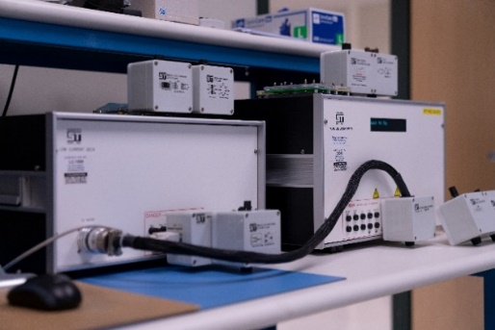
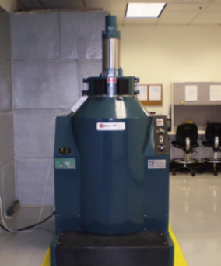

^{STI-5300} ^{GC220}
^{Figure 1. Test Setup}

DUT Bias Condition

The DUTs were irradiated under a bias voltage of +320V / +12V. See Figure 2 for bias conditions.
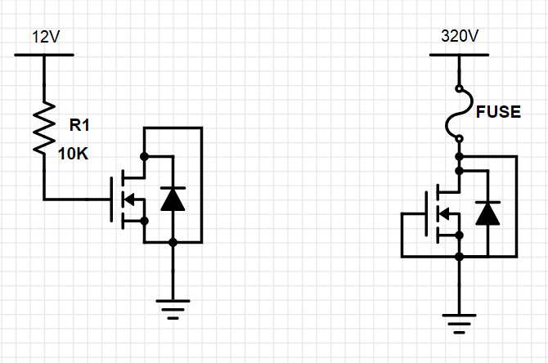
Figure 2. Bias Circuit Under Radiation
See Appendix A for an image of the DUT.

Test Parameters

See Table 2 for the list of required electrical test parameters:

^{Table 2. Test Parameters}
See APPENDIX B: MEASURED TEST PARAMETERS for the table of parametric test results.

Dosimetry

Refer to Appendix D, Exposure Report, for actual exposure levels.

LIST OF APPENDICES

APPENDIX A: IMAGE OF DUT
APPENDIX B: MEASURED TEST PARAMETERS
APPENDIX C: TRAVELER
APPENDIX D: EXPOSURE REPORT
APPENDIX E: CERTIFICATE OF CONFORMANCE

APPENDIX A: IMAGE OF DUT

MANUFACTURER: vishay
MFR PART # | IRF740PBF
TYPE | N-CHANNEL MOSFET
LOT # | S51K053.1
DATE CODE | 2411
TID BIAS | 5DUTS VDS: +320V  5DUTS VGS: +12V
# DUTS | 10 DEVICES + 2 CONTROL
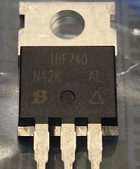

APPENDIX B: MEASURED TEST PARAMETER

DATA OUTPUT

