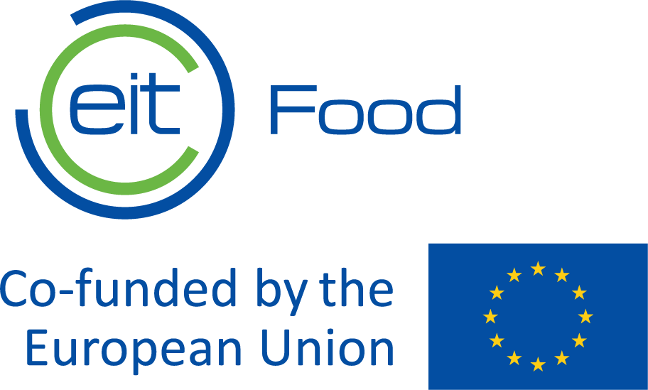

Request for proposals
Request for Proposals for Senior Communications Support Services for EIT Community Initiatives led by EIT Food

EIT Food – Making Food Innovation Happen

Knowledge & Innovation Center on Food,
part of the European Institute of Innovation and Technology (EIT)

http://www.eitfood.eu

Table of contents

Table of contents 2
1. Overview of EIT Food 3
2. Scope of work 3
3. Proposal Process 4
3.1. Submission of proposal 4
3.2. Validity of the proposals 5
3.3. Requests for additional information or clarification 5
3.4. Costs for preparing proposals 5
3.5. Ownership of the proposals 5
3.6. Clarification related to the submitted proposals 5
3.7. Negotiation about the submitted proposal 6
3.8. Evaluation of proposals 6
3.9. Appeals/complaints 6
3.10. Signature of contract 7
3.11. Cancellation of the proposal procedure 7
3.12. Ethics clauses / Corruptive practices 7
3.13. Annexes 7

Overview of EIT Food
EIT Food is Europe’s leading food innovation initiative, working to make the food system more sustainable, healthy and trusted.
The initiative is made up of a consortium of key industry players, startups, research centres and universities from across Europe. It is one of nine Innovation Communities established by the European Institute for Innovation & Technology (EIT), an independent EU body set up in 2008 to drive innovation and entrepreneurship across Europe.
EIT Food aims to collaborate closely with consumers to develop new knowledge and technology-based products and services that will ultimately deliver a healthier and more sustainable lifestyle for all European citizens.
For more information about our company please visit the following website: www.eitfood.eu

Scope of work
EIT Food is seeking proposals for the provision of senior communications support services to strengthen communication, dissemination, stakeholder engagement and visibility across EIT Community initiatives and business plan activities led by EIT Food.
Indicative budget and duration: The total available budget for this assignment is EUR 420,000 covering a period of 2.5 years. Tenderers are requested to submit a financial offer within this maximum available budget.
- Provide flexible, senior-level communications support for EIT Community initiatives and business plan activities led by EIT Food, with a focus on increasing impact, visibility and stakeholder engagement.
- Support communication and dissemination activities linked to the Innovation and Business Creation (INNOBC) Business Plan, EIT Community initiatives such as Supernovas, New European Bauhaus (NEB), AI & Robotics, and projects under the Regionalisation and Internationalisation Business Plan, including EIT Jumpstarter and the Regional Innovation Booster, with possible support to the EIT Global Platform and ECOs initiatives.
- Deliver content creation and implementation across channels, including social media copy, visuals, newsletters, email campaigns, website content, articles, news pieces and success stories, and support the development and maintenance of editorial and content calendars.
- Support and maintain EIT Community digital channels, including websites and social media, ensuring content is aligned with brand guidelines, messaging priorities and communication objectives.
- Support the planning and implementation of campaigns, initiatives, calls, events, webinars and stakeholder engagement activities, including promotional materials, live coverage and post-event communications, in coordination with internal and external stakeholders.
- Contribute to reporting and performance monitoring by preparing communication and dissemination reports, tracking key metrics, and providing recommendations for improvement.
- Ensure consistent implementation of EIT Community branding and provide proactive, hands-on communications support across evolving priorities, projects and workflows.

Proposal Process

Participation
Participation in this proposal procedure is open to all tenderers.

Submission of proposal
 | Date
Deadline for requesting clarification from EIT Food | 10 August 2026
Deadline for submitting proposals | 24 August 2026
Intended date of notification of award | 29 August 2026
Intended date of contract signature | 9 September 2026

Proposals must be emailed in English to the following address:
Contact name: for the attention of Dr. M.A. van Veelen, Director EIT Community
E-mail: martine.vanveelen@eitfood.eu
The proposal shall contain and demonstrate compliance with the following requirements:
- A technical proposal describing the proposed approach to delivering the requested services, including understanding of the assignment, methodology, organisation of work, indicative planning, and stakeholder coordination approach.
- Legal eligibility documentation confirming that the tenderer is legally established and eligible to perform the contract in accordance with the applicable legislation.
- Evidence of financial capacity, including information on annual turnover (evidence of financial stability through audited accounts for the last 2 years) sufficient to demonstrate the economic and financial standing required to perform a contract of this value.
- Evidence of technical capacity, including a minimum of three relevant references for comparable assignments performed in the recent past, demonstrating experience in senior communications support in international, EU-funded or multi-stakeholder environments.
- Relevant experience and profile information demonstrating at least 5 years of senior communications experience in international, EU-funded or multi-stakeholder environments, together with examples of comparable assignments, expertise in content creation, digital channels, campaigns, brand implementation, reporting and event communications.
- CV(s) of the proposed consultant(s), clearly outlining qualifications, language skills, and experience relevant to the assignment.
- A financial offer in EUR, indicating all applicable rates and/or total costs for the services, with VAT shown separately.
- The tender must declare absence of conflict of interest, included in the signed Declaration of Honour (Annex II).
Responses should be concise and clear. The tenderer’s proposal will be incorporated into any contract that results from this procedure. Tenderers are, therefore, cautioned not to make claims or statements that they are not prepared to commit to contractually. Subsequent modifications and counter-proposals, if applicable, shall also become an integral part of any resulting contract.
The tenderer confirms that the individual submitting the natural or legal entity’s proposal is duly authorized to bind its entity to the proposal as submitted. The tenderer also confirms that it has read the instructions to tenderers and has the experience, skills and resources to perform, according to conditions set forth in this proposal and the tenderers’ proposal.

Validity of the proposals
Tenderers are bound by their proposals for 90 days after the deadline for submitting proposals or until they have been notified of non-award.
The selected winner must maintain its proposal for a further 60 days to close the contract.
Proposals not following the instructions of this Request for Proposal can be rejected by EIT Food.

Requests for additional information or clarification
In case the tenderers require additional information or clarifications, these should be addressed to the person indicated below. All communication between EIT Food and tenderers is only possible in writing, all requests will be done and answered by e-mail only. All questions should be sent prior to deadline for requesting clarification as specified in Section 3.1. In case of complex or high value procurements, EIT Food may arrange a clarification session of which it will inform all tenderers.
Contact name: for the attention of Dr. M.A. van Veelen, Director EIT Community
E-mail: martine.vanveelen@eitfood.eu
EIT Food has no obligation to provide clarification.

Costs for preparing proposals
No costs incurred by the tenderer in preparing and submitting the proposal are reimbursable. All such costs must be borne by the tenderer.

Clarification related to the submitted proposals
After submission of the proposals, they shall be checked if they satisfy all the formal requirements set out in the proposal dossier. Where information or documentation submitted by the tenderers are or appears to be incomplete or erroneous or where specific documents are missing, EIT Food may request the tenderer concerned to submit, supplement, clarify or complete the relevant information or documentation within an appropriate time limit. All communication between EIT Food and tenderers is only possible in writing, all requests will be done and answered by e-mail only.

Negotiation about the submitted proposal
After checking the administrative compliance of the tenderers, EIT Food reserves the right to negotiate, without changing the material scope of the RFP, the contract terms with the tenderers. In this negotiation EIT Food may ask all tenderers to adjust the proposal or specific sections of the proposal within an appropriate time limit. In case of negotiation, EIT Food shall provide further information about the proceedings and timing.

Evaluation of proposals
The quality of each proposal will be evaluated in accordance with the below mentioned award criteria. The award criteria will be examined in accordance with the requested service indicated in Section 2 of the document. All evaluators shall sign a declaration of absence of conflict of interest and confidentiality.
The quality of each proposal will be assessed on the basis of the following award criteria. Each technical sub-criterion will be scored on a scale from 0 to 5, where 0 = not addressed or unacceptable, 1 = very poor (insufficient), 2 = poor, 3 = satisfactory (meets requirement but limited detail) , 4 = good, and 5 = excellent (fully meets requirement with added value and clear methodology). The weighted score for each criterion will then be calculated according to its maximum available points.
Award criteria for this procedure are as follows:
- Relevant experience of the tenderer and the proposed consultant(s), including demonstrated experience in senior communications roles in international, EU-funded or multi-stakeholder environments, and proven ability to deliver similar assignments (maximum: 25 points)
- Quality and relevance of the proposed methodology, including understanding of the assignment, organisation of work, flexibility, stakeholder coordination and ability to work across multiple projects and priorities (maximum: 20 points)
- Quality of communication expertise demonstrated, including content creation, channel management, campaign support, brand implementation, reporting, event communication support, and ability to adapt messaging to different audiences and formats (maximum: 15 points)
Total technical score: 60 points maximum
To be considered for financial evaluation, proposals must achieve a minimum technical threshold of 70% of the maximum technical score, i.e. at least 42 out of 60 points. Proposals that do not reach this threshold may be excluded from further consideration.
- Financial offer and overall cost-effectiveness of the proposed services. The lowest priced compliant offer will receive the highest score, and other offers will be scored proportionally using the following formula: financial score = (lowest compliant price / price of the tender under evaluation) x 40 points (maximum: 40 points)
Total financial score: 40 points maximum
Total maximum score: 100 points
The results of the award procedure will be communicated in writing (via e-mail) to the successful and unsuccessful tenderers.

Appeals/complaints
Tenderers believing that they have been harmed by an error or irregularity during the award process may file a complaint. Appeals should be addressed to EIT Food. The tenderers have 10 calendar days to file their complaints from the dispatch of the award notification e-mail.

Signature of contract
Please refer to Annex 1 for the template contract that shall apply to this procedure. Any changes desired by the tenderer in the provisions contained in the body of this Service Agreement must be communicated to EIT Food as part of the proposal of such tenderer. Any such changes will be considered as part of the evaluation of the proposal of each tenderer
Within 5 days of receipt of the contract from EIT Food, the winning tenderer shall sign and date the contract and return it to EIT Food. Upon receipt, EIT Food shall countersign and return one signed copy of the contract to the winning tenderer.

Cancellation of the proposal procedure
In the event of cancellation of the procurement procedure, EIT Food will notify tenderers of the cancellation. In no event shall EIT Food be liable for any damages whatsoever including, without limitation, damages for loss of profits, in any way connected with the cancellation of a proposal procedure, even if EIT Food has been advised of the possibility of damages.

Ethics clauses / Corruptive practices
EIT Food reserves the right to suspend or cancel the procedure, where the award procedure proves to have been subject to substantial errors, irregularities or fraud. If substantial errors, irregularities or fraud are discovered after the award of the Contract, EIT Food may refrain from concluding the Contract.
The supplier shall take all measures to prevent any situation where the impartial and objective implementation of the contract is compromised for reasons involving economic interest, political or national affinity, family or emotional ties or any other shared interest (‘conflict of interests’). The supplier should immediately inform EIT Food if there is any change in the above circumstances at any stage during the implementation of the tasks.
Tenderers must comply with GDPR.

Annexes
Annex 1: Contract Template. The Contract Template is provided for information purposes only and might be subject to considerable modifications.
Annex II: Declaration of Honour

