

Supporting Information
Supplementary results
This appendix was part of the submitted manuscript and has been peer reviewed.
It is posted as supplied by the authors.

Appendix to: Marzan MB, Johnson E, Moore P, et al. Changes in the numbers of hospital-based abortions and outpatient early medical abortions in Victoria, 2012–22: a retrospective cohort study. Med J Aust 2024; doi: 10.5694/mja2.00000.

Figure 1. Pregnancy terminations, Victoria, 1 January 2012 – 31 March 2022, by age group of women: time series analyses*
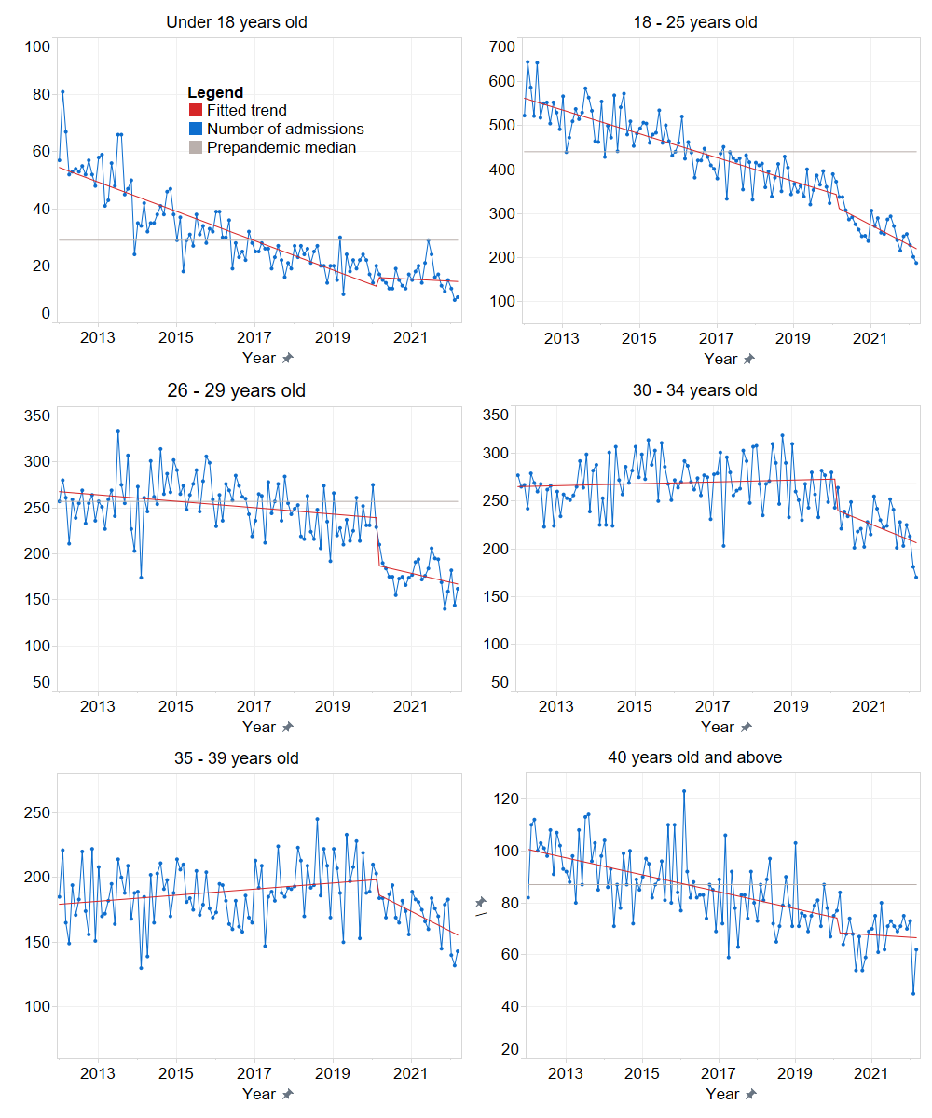
* Adjusted for autocorrelation and seasonality.

Figure 2. Pregnancy terminations, Victoria, 1 January 2012 – 31 March 2022, by postcode-based socio-economic status (IRSAD quintile): time series analyses*
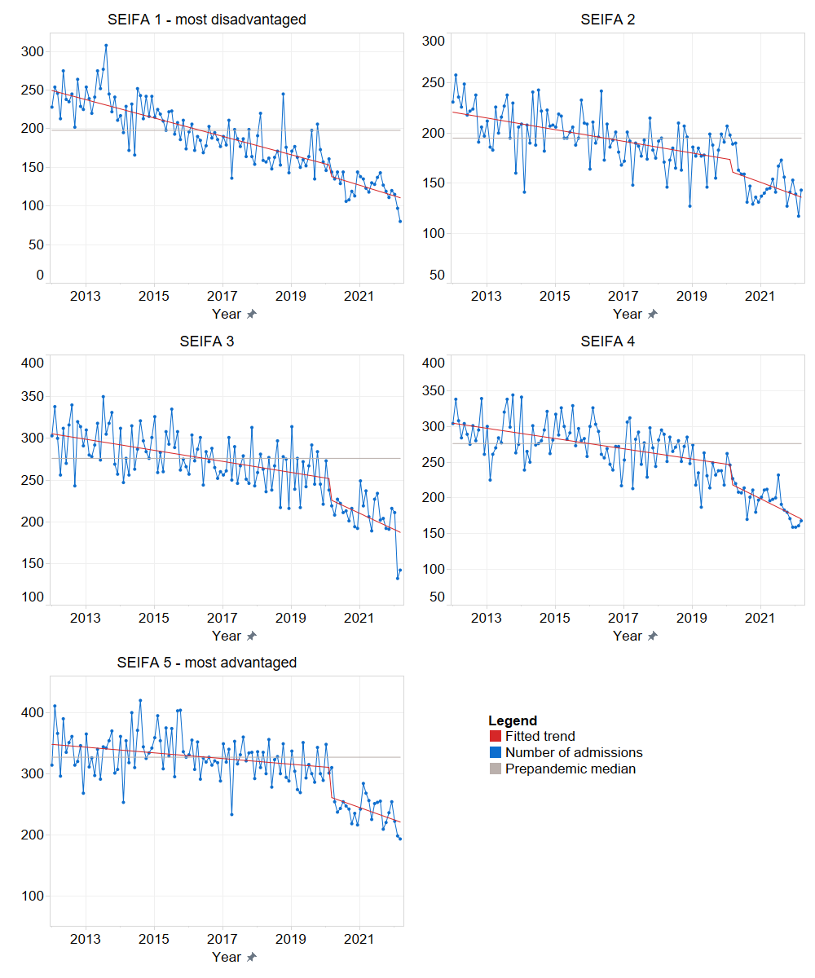
* Adjusted for autocorrelation and seasonality. IRSAD = Index of Relative Socio-economic Advantage and Disadvantage.

Figure 3. Pregnancy terminations, Victoria, 1 January 2012 – 31 March 2022, by gestational age at termination: time series analyses*
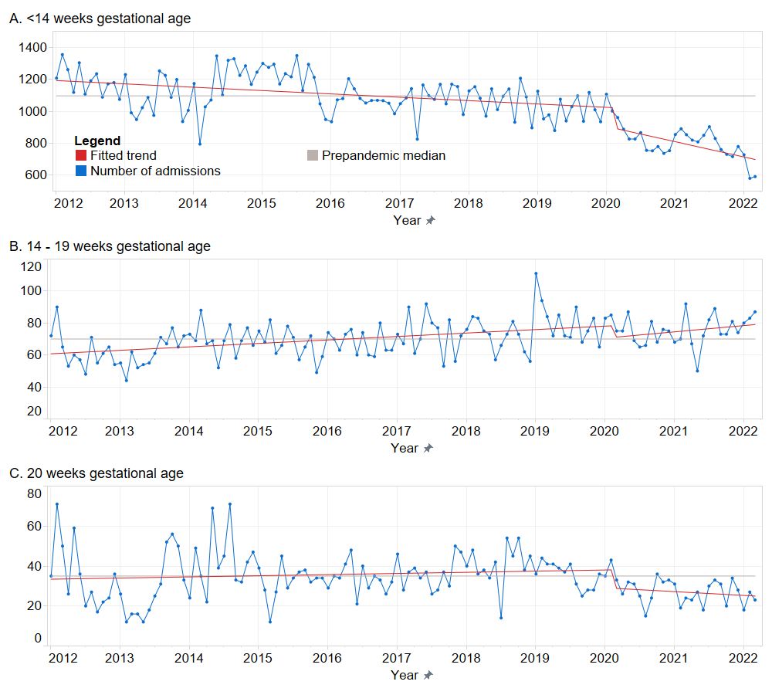
* Adjusted for autocorrelation and seasonality.

Figure 4. Pregnancy terminations, Victoria, 1 January 2012 – 31 March 2022, by geographic remoteness and hospital type: time series analyses*
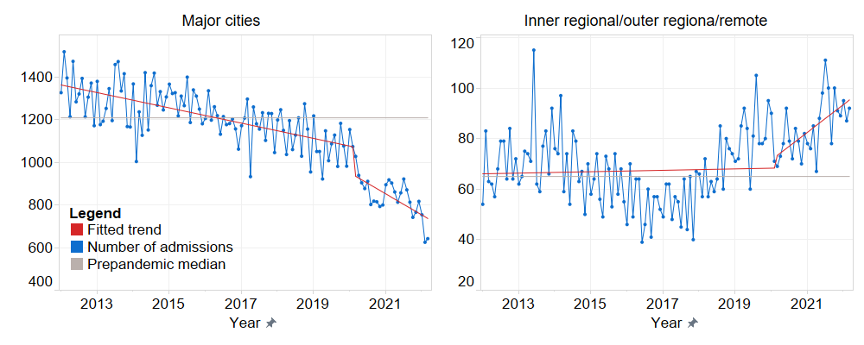
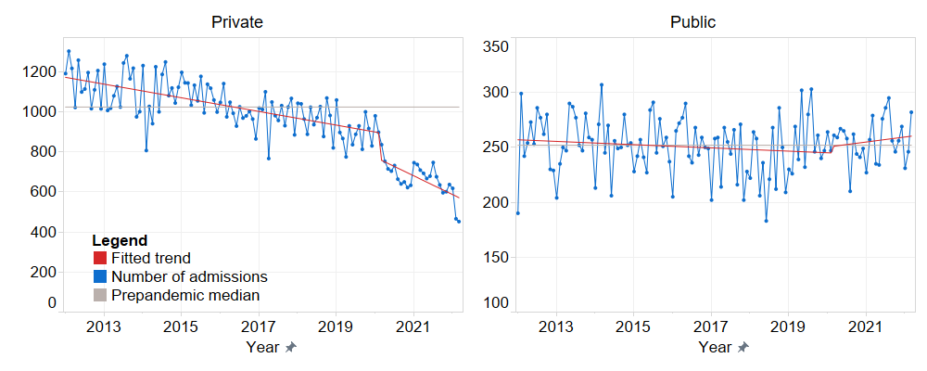
* Adjusted for autocorrelation and seasonality.

Figure 5. Pregnancy terminations per 1000 births, Victoria, 1 January 2012 – 31 March 2022, by termination type: time series analyses*
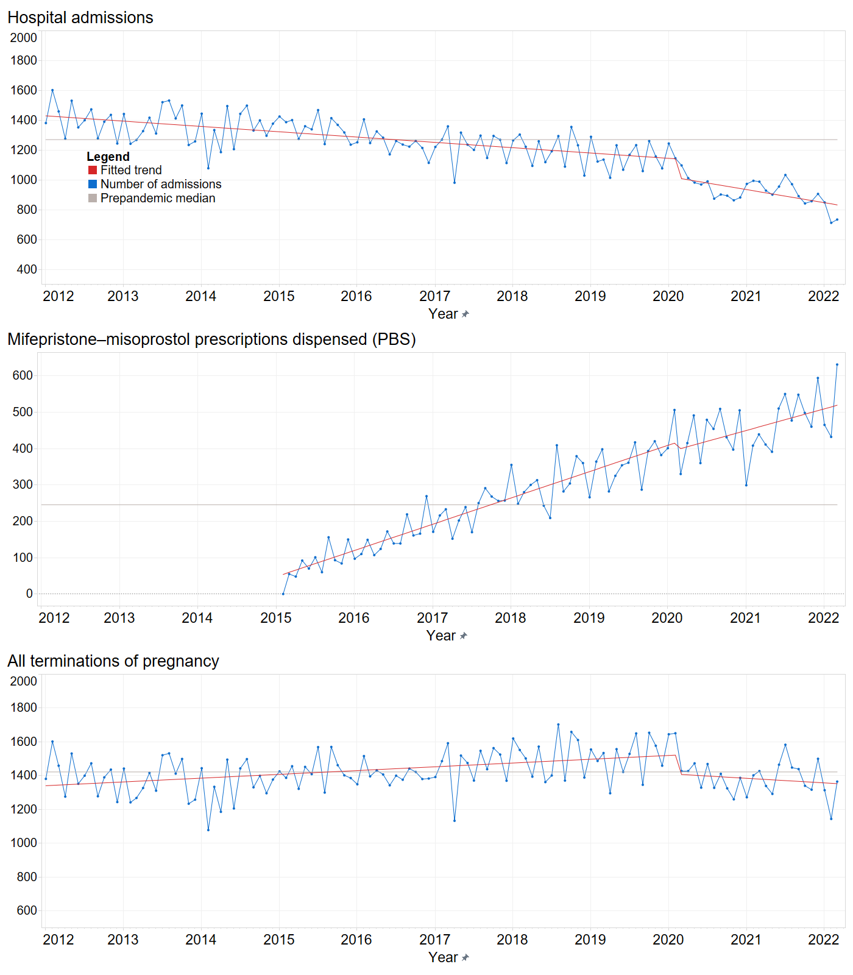
* Adjusted for autocorrelation and seasonality.

Table 1: Sensitivity analysis: Pregnancy terminations per 1000 births, Victoria, 1 January 2012 – 31 March 2022, by termination type: time series analyses*

 | Slope (95% confidence interval)
Characteristic | Pre–pandemic period  (Jan 2012–Mar 2020) | First month of pandemic (Apr 2020) | Pandemic period  (May 2020–Mar 2022)
All abortions | 0.25 (0.14 to 0.37) | –10.1 (–25.4 to 5.13) | –1.28 (–2.29 to –0.26)
Hospital-based abortions | –0.51 (–0.60 to –0.42) | –16.30 (–28.2 to –4.41) | –1.02 (–1.81 to –0.23)
Outpatient early medical abortions | 0.77 (0.69 to 0.84) | 2.62 (–6.78 to 12.0) | –0.05 (–0.67 to 0.57)

* Adjusted for autocorrelation and seasonality.

