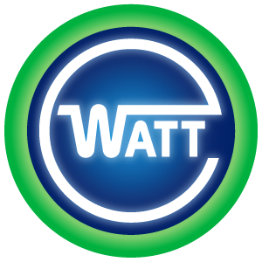
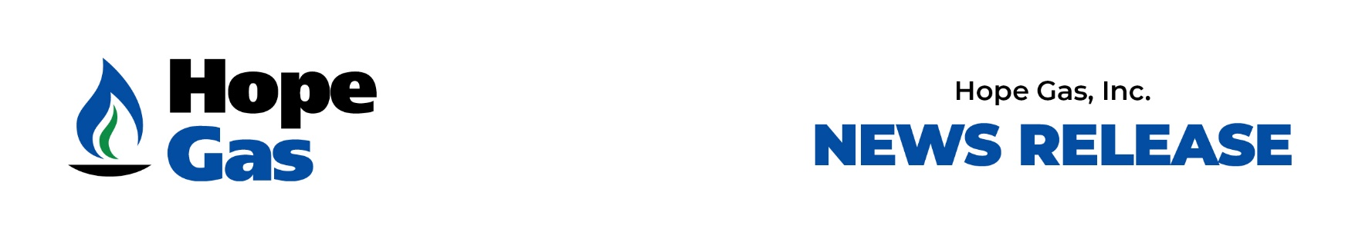

FOR IMMEDIATE RELEASE

June 24, 2025

Hope Gas and WATT Fuel Cell Launch Innovative WATT HOME™ Solid Oxide Fuel Cell Backup Power Leasing Program to Strengthen Grid Resiliency Across West Virginia
Program Committed to Initially Deploy 7,250 Units Over Three Years, Marking the Largest Residential Fuel Cell Initiative in the Country

MORGANTOWN, WV – In a major step forward for distributed energy solutions in Appalachia, WATT Fuel Cell Corp and Hope Gas proudly announce the launch of a groundbreaking exclusive Hope Gas customer program for the WATT HOME fuel cell system. This strategic partnership will initially make over 7,250 next-generation backup power configured fuel cell units exclusively available to Hope Gas residential customers across West Virginia over the next three years, directly addressing the state’s pressing need for reliable, resilient power utilizing the state’s plentiful and reliable natural gas.

Electric power outages are more than an inconvenience. For families and businesses, they can disrupt everyday life. West Virginia experiences among the most challenging electric reliability in the country according to the U.S. Energy Information Administration’s Annual Electric Power Industry Report. The state sees some of the most frequent power outages and longest blackout times in the country. Hope Gas customers in West Virginia will have access to cutting-edge WATT Fuel Cell technology to provide back-up power to their homes starting in 2026.

The innovative program exclusively offers Hope Gas customers access to the WATT HOME system—an advanced solid oxide fuel cell (SOFC) technology that operates efficiently on readily available natural gas. Designed for residential use, WATT HOME provides dependable, low-emission electricity even when the power grid is down.

“Hope Gas is excited to partner with WATT to bring this innovative fuel cell technology to the families we serve in West Virginia,” said Morgan O’Brien, chief executive officer of Hope Gas. “Hope has thousands of miles of existing natural gas distribution infrastructure throughout the Mountain State that reliably delivers natural gas to the homes we serve even when the electric power is out. The WATT HOME systems available through this partnership will create back-up power for homes using natural gas when there is an electric outage. Hope Gas is constantly exploring innovative ways to provide cutting-edge solutions to our customers and communities. Leasing this technology will avoid any up-front capital outlay for Hope customers. This partnership with WATT is revolutionizing utility service reliability for our customers.”
The deployment of 7,250 WATT HOME systems marks the largest residential fuel cell initiative in the country. It also highlights West Virginia’s leadership in modern energy innovation, with the potential to serve as a national model for partnerships that solve local infrastructure challenges with distributed energy resources.

“This partnership between Hope Gas and WATT Fuel Cell represents a powerful shift in how we think about residential energy,” said Caine Finnerty, CEO of WATT Fuel Cell. “By combining our scalable, innovative technology with the trusted service of Hope Gas, we’re empowering West Virginians to take greater control of their energy future.”

The leasing model ensures affordability and ease of adoption, giving Hope Gas customers a no-hassle option for energy independence without large upfront capital investments. The program is expected to be especially impactful as grid vulnerability continues to grow with increased extreme weather events and longer duration outages.

“Hope Gas is committed to innovation that serves our customers and strengthens West Virginia,” said O'Brien. “The WATT HOME system gives our customers access to cutting-edge energy technology that supports their homes, their safety, and the state’s long-term energy resilience.”

Key highlights:

- Access to WATT’s fuel cells: WATT Fuel Cell will lease 7,250 WATT HOME systems configured to provide homes with backup power to Hope Gas residential customers. Leases will be available starting in 2026 for 750 systems. An additional 2500 systems will be available in 2027, and 4000 more systems will be available in 2028.

- Lease information: There will be no upfront costs to customers when entering the lease for the WATT HOME system. Each lease term will be 10 years. The monthly lease fees will be added to the customer’s Hope Gas bill. At the end of the lease term, customers may extend the lease or return the system.

- Installation & Maintenance: Hope Gas will provide installation and maintenance support for each system for the length of the lease. Installation and maintenance are included in the lease and will not result in additional costs.

- Timeline: Hope Gas customers will have access to leases for 750 WATT HOME systems starting in 2026.

Media Contacts:
Hope Gas WATT Fuel Cell
Erin O’Donnell Danielle Ramaley
Erin.g.odonnell@hopegas.com danielle.ramaley@wattfuelcell.com
847-738-3118 724-882-6645

###

About Hope Gas: Hope Gas is a Local Distribution Company (LDC) that proudly provides gas service to approximately 140,000 residential, industrial, and commercial customers in thirty-eight West Virginia counties. We monitor and maintain over 7000 miles of pipelines that safely deliver West Virginia natural gas to many homes and commercial and industrial sites. We currently employ nearly 600 employees working right here in our beautiful Mountain State with the sole purpose of staying true to our company’s mission and vision in West Virginia. Learn more at HopeGas.com.

About Hope Utilities: Hope Utilities owns natural gas and water distribution utilities across eight states. We provide service to more than 200,000 residential, commercial, and industrial customers in the communities we serve. We currently operate natural gas utilities in West Virginia, Indiana, Montana, North Carolina, and Ohio; and water and wastewater utilities in Arizona, Michigan, and Texas. Hope’s growth strategy is built on being a trusted member of the communities we serve, providing our customers with safe, reliable, and cost-effective utility service. Learn more about Hope at HopeUtilities.com

About WATT Fuel Cell: WATT Fuel Cell (www.wattfuelcell.com) is a manufacturer and developer of Solid Oxide Fuel Cell (“SOFC”) stacks and systems that operate on common, readily available fuels such as propane and natural gas. WATT’s proprietary, patented additive manufacturing process (AMP) has allowed it to produce commercially viable SOFC products for small-scale and remote power applications. WATT’s Hybrid Power Management system works in tandem with renewable power sources (solar and wind) and energy storage to provide quiet, efficient, affordable, and environmentally responsible energy solutions prioritizing a return on investment for customers across the globe.

