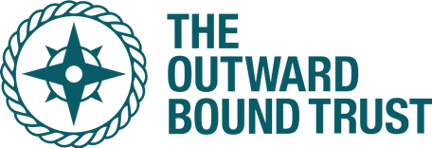
All pledges, cheques and monies donated must be in £ Sterling and made payable to The Outward Bound Trust
If I have ticked the Gift Aid box? I confirm that I am a UK Income or Capital Gains taxpayer. I understand the charity will reclaim 25p of tax on every £1 that I have given. I have read this statement and want the charity named above to reclaim tax on the donation detailed above, given on the date shown. I understand that I must pay an amount of Income Tax and/or Capital Gains Tax in the tax year at least equal to the amount of tax that all the charities and CASCs I donate to, will reclaim on my gifts for that tax year. I understand that other taxes such as VAT and Council Tax do not qualify.
Sponsor’s full name  (first name and surname ) | Home address  (Only needed if you’re Gift Aiding your donation) | Postcode | Donation amount £ | Gift Aid | Signature | Date paid

Name of fundraiser: …………………………..
SPONSORSHIP FORM AND GIFT AID DECLARATION
The Outward Bound Trust are an educational charity that inspires young people to believe they can be more than they ever thought possible.w
On the 23rd of April insert name
is running the London Marathon and raising money for

