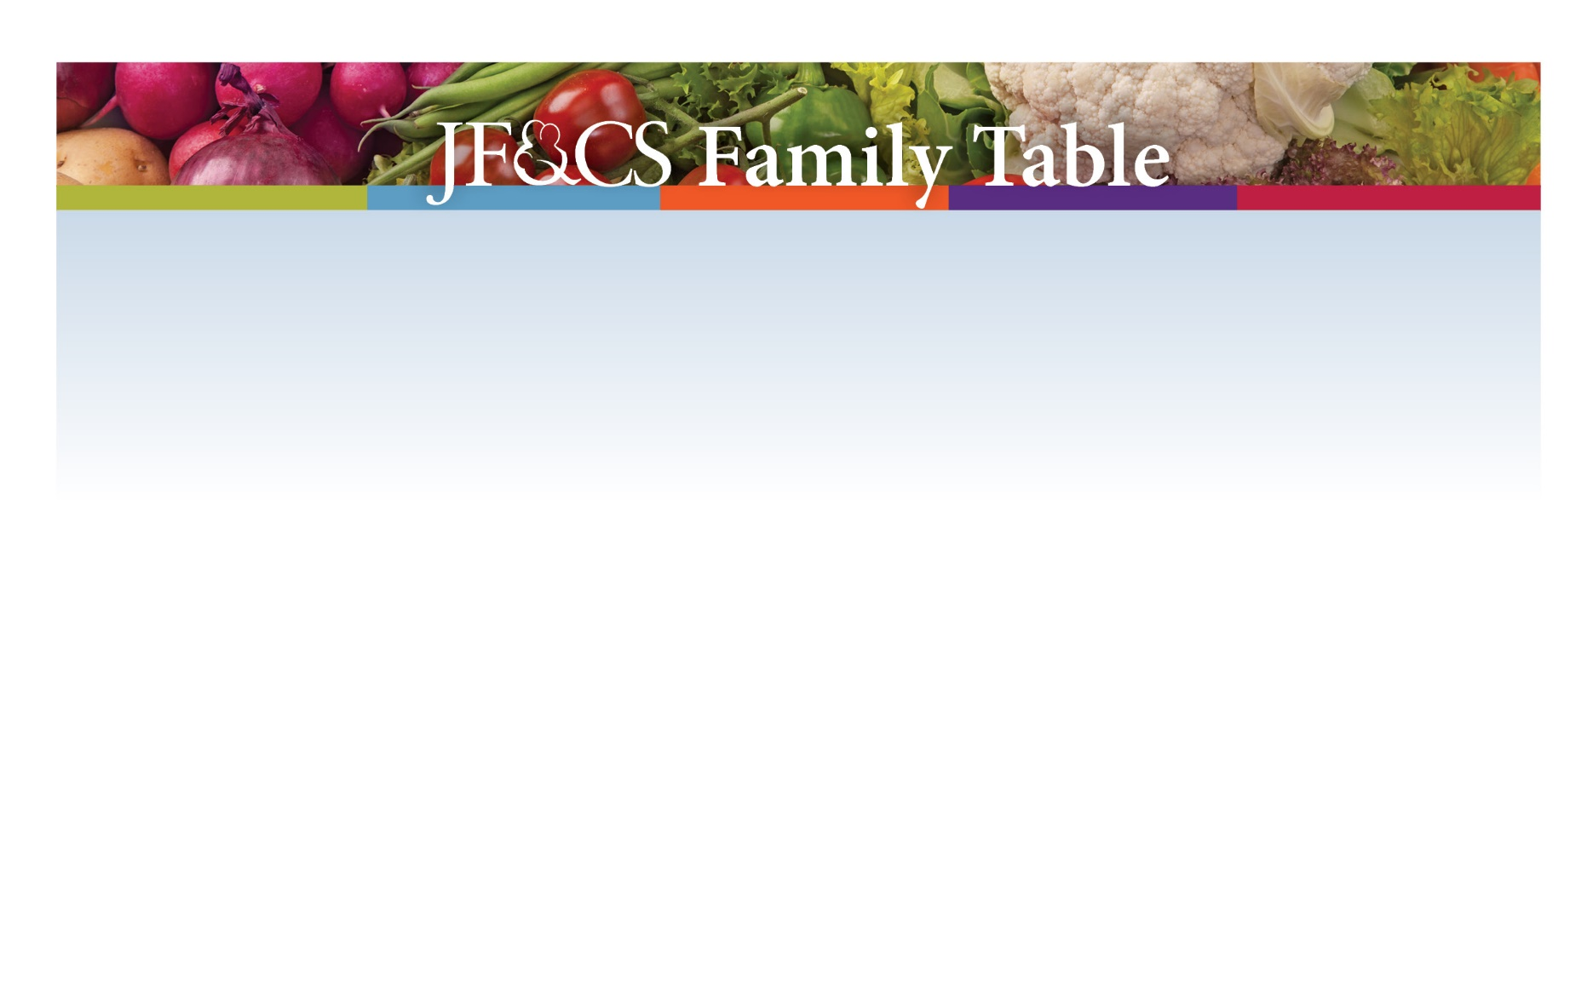

The Mission of Family Table is to end hunger in the Greater Boston Jewish Community while serving people who need our assistance regardless of their religious affiliation.

Family Table fulfills its mission by providing kosher food, creating a caring Jewish connection, an empowering people to make healthy eating a part of their daily lives.

JF&CS Family Table serves 100 communities in Eastern Massachusetts with locations in Waltham, Marblehead, and Canton. With your support and the support of an extraordinary network of 70 synagogues, day schools, and community centers, Family Table provides nutritious groceries, Jewish holiday items, and a vital connection to a caring Jewish community to more than 550 families each month.

For more information, email familytable@jfcsboston.org or call 781-693-5593.

