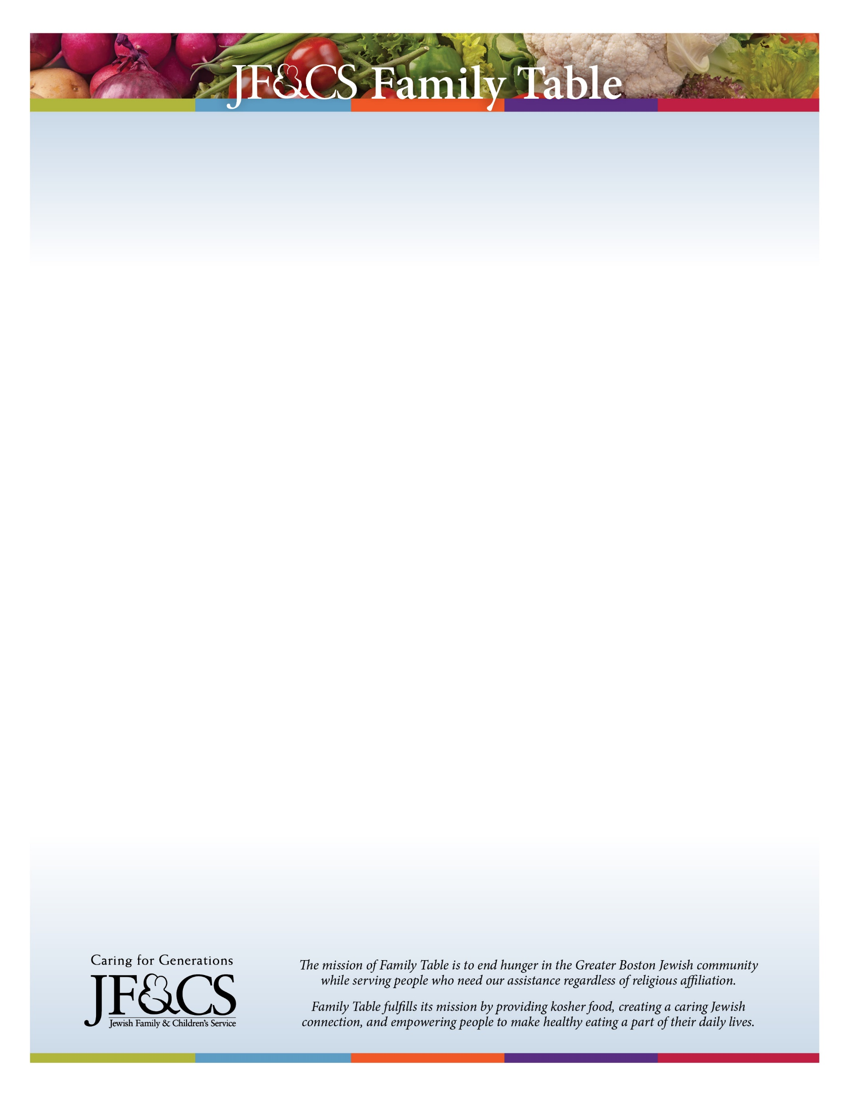

Help end hunger in our community with JF&CS Family Table!
Family Table serves 100 communities in Eastern Massachusetts and we are currently providing food for more than 550 households each month through our three locations in Waltham, Canton, and Marblehead.

Volunteers are needed to pack and deliver groceries to several assigned families in Greater Boston. Packing food takes 30-45 minutes and deliveries are convenient to the volunteer’s hometown.
New volunteers will receive a private orientation when they arrive.

Online registration and a CORI are due at least two weeks in advance of a distribution for volunteering.

To get involved, please contact familytable@jfcsboston.org or 781-693-5593.
Visit www.jfcsboston.org/familytable for more information.

